DIA 1 23/03/2026

CREACION DEL REPOSITORIO DE GIT

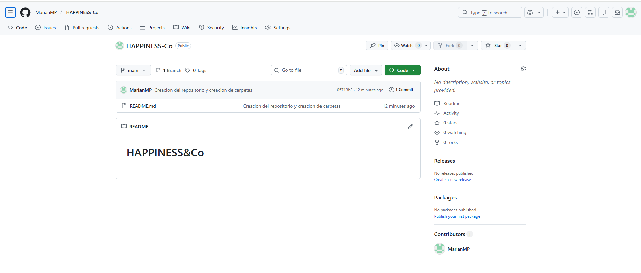

CREACION DE LA ESTRUCTURA DE CARPETAS
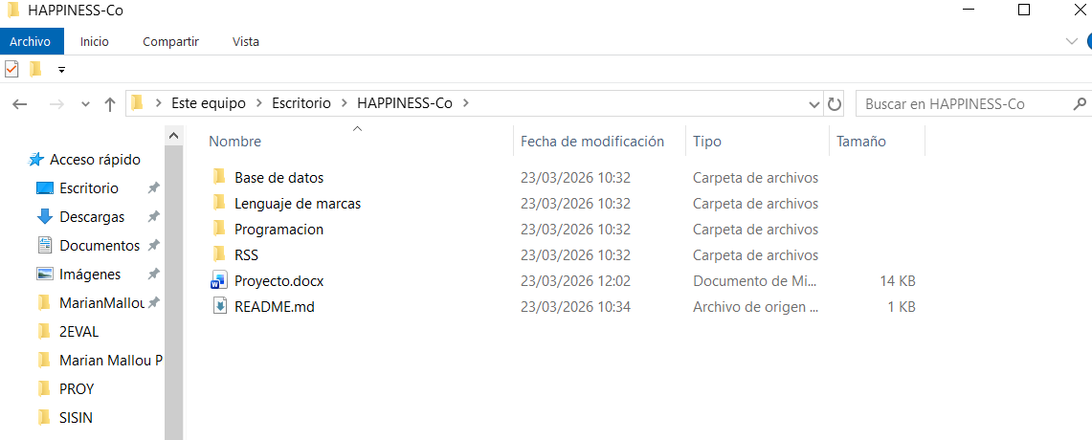

CREACION DEL MOCKUP

DIA 2 24/03/2026

CREACION DEL DISEÑO CON FIGMA
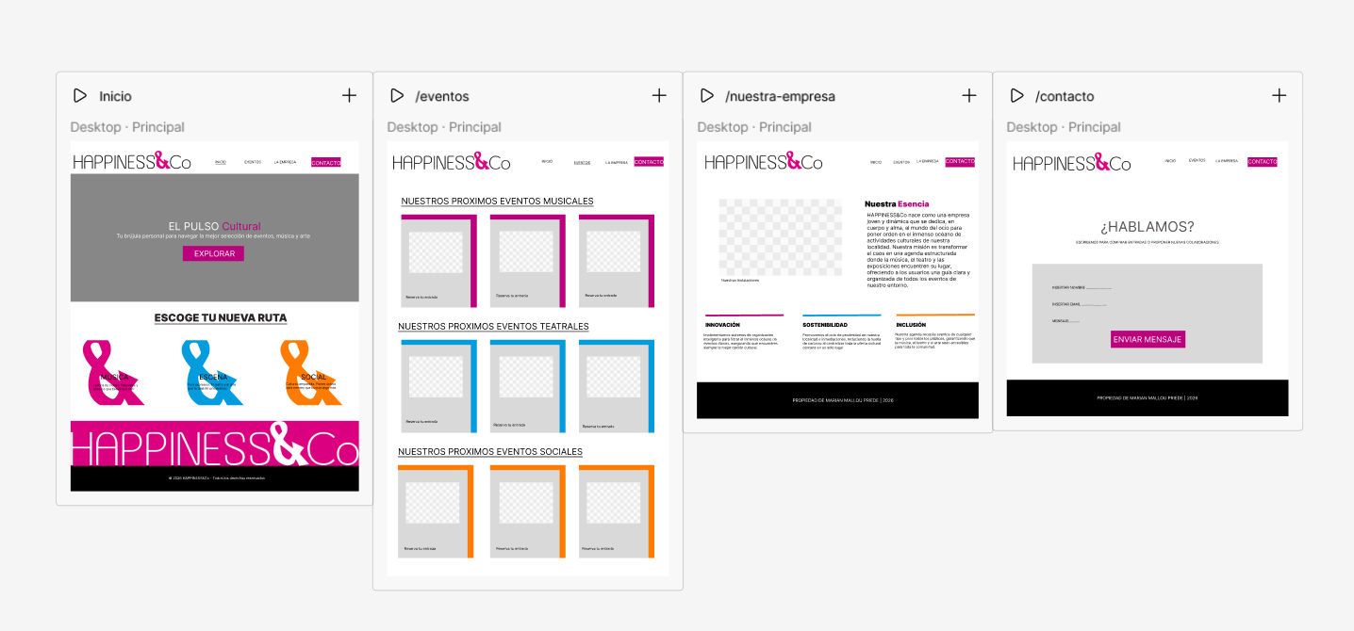

CREACION DE PARTE DEL INDEX.HTML

DIA 3 25/03/2026

ACABAR EL MOCK UP:

EMPEZAR CON LOS .HTML:
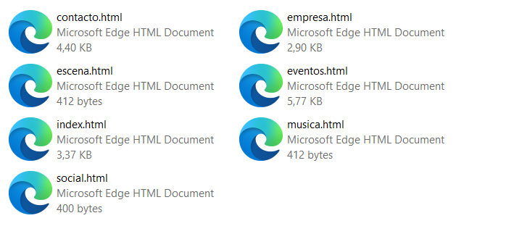

DIA 4 26/03/2026

MODIFICAR EL MOCK UP Y TERMINARLO

CREAR MAS ARCHIVOS .HTML

EDITAR LOS .HTML QUE YA TENIA

DIA 5 27/03/2026

MODIFICAR LOS ARCHIVOS HTML

SUBIR A GIT TODO LO HECHO

CREAR BASE DE DATOS EN MYSQL WORKBENCH

MODIFICAR EL README.MD

DIA 6 06/04/2026

DIA 7 07/04/2026

DIA 8 08/04/2026

CREAR EL PROYECTO DE JAVA

INSERTAR IMÁGENES EN LOS HTML

DIA 9 09/04/2026

INSERTAR LOS DATOS EN LA BASE DE DATOS

INSERTAR IMÁGENES EN LOS HTML Y CREAR LOS ULTIMOS HTML DE LA INFORMACION DE CADA EVENTO

DIA 10/04/2026

08/04/2026

Subida de archivos hasta que se sobreescribio y se borro
ALUMNOS-FP@DESKTOP-NI3I5TT MINGW64 ~/Desktop/HAPPINESS-Co (main)
$ git init
Reinitialized existing Git repository in C:/Users/ALUMNOS-FP/Desktop/HAPPINESS-Co/.git/

ALUMNOS-FP@DESKTOP-NI3I5TT MINGW64 ~/Desktop/HAPPINESS-Co (main)
$ git add .
warning: in the working copy of 'README.md', LF will be replaced by CRLF the next time Git touches it
warning: in the working copy of 'Base de datos/Base datos Happiness&Co.sql', LF will be replaced by CRL
F the next time Git touches it
warning: in the working copy of 'Lenguaje de marcas/Assets/img/festivalcine.htm', LF will be replaced b
y CRLF the next time Git touches it

ALUMNOS-FP@DESKTOP-NI3I5TT MINGW64 ~/Desktop/HAPPINESS-Co (main)
$ git commit -m "Subida del proyecto entero hasta el momento"
[main a5e8c87] Subida del proyecto entero hasta el momento
78 files changed, 3902 insertions(+), 494 deletions(-)
create mode 100644 Base de datos/Base datos Happiness&Co.sql
create mode 100644 Lenguaje de marcas/Assets/img/BELLASARTES.jpg
create mode 100644 Lenguaje de marcas/Assets/img/BOMBASTIC.jfif
create mode 100644 Lenguaje de marcas/Assets/img/CABRALES.jfif
create mode 100644 Lenguaje de marcas/Assets/img/FERIADEMUESTRAS.JPEG
create mode 100644 Lenguaje de marcas/Assets/img/LGTBI_NIEMEYER.jpg
create mode 100644 Lenguaje de marcas/Assets/img/MIERES.jfif
create mode 100644 Lenguaje de marcas/Assets/img/Miserables2.jpg
create mode 100644 Lenguaje de marcas/Assets/img/NEGRA.jfif
create mode 100644 Lenguaje de marcas/Assets/img/NIEMEYER.jfif
create mode 100644 Lenguaje de marcas/Assets/img/RALLY.jfif
create mode 100644 Lenguaje de marcas/Assets/img/REYLEON.jfif
create mode 100644 Lenguaje de marcas/Assets/img/SANXUAN.jfif
create mode 100644 Lenguaje de marcas/Assets/img/SELLA.jfif
create mode 100644 Lenguaje de marcas/Assets/img/SIDRA.jfif
create mode 100644 Lenguaje de marcas/Assets/img/TEATRO-LANGREO.jfif
create mode 100644 Lenguaje de marcas/Assets/img/TOSCA.jfif
create mode 100644 Lenguaje de marcas/Assets/img/aitana.png
create mode 100644 Lenguaje de marcas/Assets/img/atour.jfif
create mode 100644 "Lenguaje de marcas/Assets/img/a\303\261o.jfif"
create mode 100644 "Lenguaje de marcas/Assets/img/a\303\261o2.jfif"
create mode 100644 Lenguaje de marcas/Assets/img/bollo.jfif
create mode 100644 Lenguaje de marcas/Assets/img/bollo2.jfif
create mode 100644 Lenguaje de marcas/Assets/img/celestina.jpg
create mode 100644 Lenguaje de marcas/Assets/img/circosol.jfif
create mode 100644 Lenguaje de marcas/Assets/img/circosol2.jfif
create mode 100644 Lenguaje de marcas/Assets/img/comic.jpg
create mode 100644 Lenguaje de marcas/Assets/img/comic2.jfif
create mode 100644 Lenguaje de marcas/Assets/img/covadonga.jpg
create mode 100644 Lenguaje de marcas/Assets/img/dali.jfif
create mode 100644 Lenguaje de marcas/Assets/img/dali2.jfif
create mode 100644 Lenguaje de marcas/Assets/img/ferialibro.png
create mode 100644 Lenguaje de marcas/Assets/img/ferialibro2.jfif
create mode 100644 Lenguaje de marcas/Assets/img/festivalcine.htm
create mode 100644 Lenguaje de marcas/Assets/img/festivalcine.jfif
create mode 100644 Lenguaje de marcas/Assets/img/festivalcine2.jfif
create mode 100644 Lenguaje de marcas/Assets/img/gijon-sound.jfif
create mode 100644 Lenguaje de marcas/Assets/img/hamlet.jpg
create mode 100644 Lenguaje de marcas/Assets/img/hamlet2.jfif
create mode 100644 Lenguaje de marcas/Assets/img/melendi.jfif
create mode 100644 Lenguaje de marcas/Assets/img/melendi2.jfif
create mode 100644 Lenguaje de marcas/Assets/img/miserables.jfif
create mode 100644 Lenguaje de marcas/Assets/img/morla.jfif
create mode 100644 Lenguaje de marcas/Assets/img/navidad.jfif
create mode 100644 Lenguaje de marcas/Assets/img/navidad2.jfif
create mode 100644 Lenguaje de marcas/Assets/img/puente.jpg
create mode 100644 Lenguaje de marcas/Assets/img/queso.jfif
create mode 100644 Lenguaje de marcas/Assets/img/queso2.jfif
create mode 100644 Lenguaje de marcas/Assets/img/r.jpg
create mode 100644 Lenguaje de marcas/Assets/img/r2.jfif
create mode 100644 Lenguaje de marcas/Assets/img/rodrigo.jfif
create mode 100644 Lenguaje de marcas/Assets/img/sidra-cata.jfif
create mode 100644 Lenguaje de marcas/Assets/img/teatro-jovellanos.jpg
create mode 100644 Lenguaje de marcas/Assets/img/tour.jfif
create mode 100644 Lenguaje de marcas/Assets/img/trail.jfif
create mode 100644 Lenguaje de marcas/Assets/img/trail2.jfif
create mode 100644 Lenguaje de marcas/Assets/img/vetustamorla.jfif
create mode 100644 Lenguaje de marcas/extras.html
create mode 100644 Lenguaje de marcas/fuentes.html
create mode 100644 Lenguaje de marcas/historial.html
create mode 100644 Lenguaje de marcas/inicioSesion.html
create mode 100644 Programacion/Happiness&Co/build.xml
create mode 100644 Programacion/Happiness&Co/manifest.mf
create mode 100644 Programacion/Happiness&Co/nbproject/build-impl.xml
create mode 100644 Programacion/Happiness&Co/nbproject/genfiles.properties
create mode 100644 Programacion/Happiness&Co/nbproject/project.properties
create mode 100644 Programacion/Happiness&Co/nbproject/project.xml
create mode 100644 Programacion/Happiness&Co/src/happiness/co/HappinessCo.java

ALUMNOS-FP@DESKTOP-NI3I5TT MINGW64 ~/Desktop/HAPPINESS-Co (main)
$ git remote add origin https://github.com/MarianMP/HAPPINESS-Co.git
error: remote origin already exists.

ALUMNOS-FP@DESKTOP-NI3I5TT MINGW64 ~/Desktop/HAPPINESS-Co (main)
$ git push -u origin main --force
Enumerating objects: 163, done.
Counting objects: 100% (163/163), done.
Delta compression using up to 8 threads
Compressing objects: 100% (151/151), done.
Writing objects: 100% (163/163), 6.70 MiB | 2.27 MiB/s, done.
Total 163 (delta 18), reused 0 (delta 0), pack-reused 0 (from 0)
remote: Resolving deltas: 100% (18/18), done.
To https://github.com/MarianMP/HAPPINESS-Co.git
+ 3d70086...a5e8c87 main -> main (forced update)
branch 'main' set up to track 'origin/main'.

ALUMNOS-FP@DESKTOP-NI3I5TT MINGW64 ~/Desktop/HAPPINESS-Co (main)
$ git reflog
a5e8c87 (HEAD -> main, origin/main) HEAD@{0}: commit: Subida del proyecto entero hasta el momento
19d95c9 HEAD@{1}: commit (merge): Merge branch 'main' of https://github.com/MarianMP/HAPPINESS-Co
48f98e3 HEAD@{2}: commit: Crear diseño de la pagina web en Figma
693a368 HEAD@{3}: commit: Crear el index del proyecto de Lenguaje de marcas
05713b2 HEAD@{4}: Branch: renamed refs/heads/master to refs/heads/main
05713b2 HEAD@{6}: commit (initial): Creacion del repositorio y creacion de carpetas

ALUMNOS-FP@DESKTOP-NI3I5TT MINGW64 ~/Desktop/HAPPINESS-Co (main)
$ git checkout -b rescate 3d70086
fatal: '3d70086' is not a commit and a branch 'rescate' cannot be created from it

ALUMNOS-FP@DESKTOP-NI3I5TT MINGW64 ~/Desktop/HAPPINESS-Co (main)
$ git checkout -b rescate 19d95c9
Unlink of file 'proyecto.docx' failed. Should I try again? (y/n) y
Unlink of file 'proyecto.docx' failed. Should I try again? (y/n) n
error: unable to unlink old 'proyecto.docx': Invalid argument
Updating files: 100% (78/78), done.
M proyecto.docx
Switched to a new branch 'rescate'

ALUMNOS-FP@DESKTOP-NI3I5TT MINGW64 ~/Desktop/HAPPINESS-Co (rescate)
$ git checkout -b rescate 19d95c9
fatal: a branch named 'rescate' already exists

ALUMNOS-FP@DESKTOP-NI3I5TT MINGW64 ~/Desktop/HAPPINESS-Co (rescate)
$ git checkout main
error: Your local changes to the following files would be overwritten by checkout:
proyecto.docx
Please commit your changes or stash them before you switch branches.
Aborting

ALUMNOS-FP@DESKTOP-NI3I5TT MINGW64 ~/Desktop/HAPPINESS-Co (rescate)
$ ^[[200~git stash~
bash: $'\E[200~git': command not found

ALUMNOS-FP@DESKTOP-NI3I5TT MINGW64 ~/Desktop/HAPPINESS-Co (rescate)
$ git stash
Saved working directory and index state WIP on rescate: 19d95c9 Merge branch 'main' of https://github.c
om/MarianMP/HAPPINESS-Co
Unlink of file 'proyecto.docx' failed. Should I try again? (y/n) y
Unlink of file 'proyecto.docx' failed. Should I try again? (y/n) n
error: unable to unlink old 'proyecto.docx': Invalid argument
fatal: Could not reset index file to revision 'HEAD'.

ALUMNOS-FP@DESKTOP-NI3I5TT MINGW64 ~/Desktop/HAPPINESS-Co (rescate)
$ git stash
Saved working directory and index state WIP on rescate: 19d95c9 Merge branch 'main' of https://github.c
om/MarianMP/HAPPINESS-Co

ALUMNOS-FP@DESKTOP-NI3I5TT MINGW64 ~/Desktop/HAPPINESS-Co (rescate)
$ git checkout main
Switched to branch 'main'
Your branch is up to date with 'origin/main'.

ALUMNOS-FP@DESKTOP-NI3I5TT MINGW64 ~/Desktop/HAPPINESS-Co (main)
$ git merge rescate
Already up to date.

ALUMNOS-FP@DESKTOP-NI3I5TT MINGW64 ~/Desktop/HAPPINESS-Co (main)
$ git push origin main
Everything up-to-date

ALUMNOS-FP@DESKTOP-NI3I5TT MINGW64 ~/Desktop/HAPPINESS-Co (main)
$

